CSA1519- CLOUD COMPUTING FOR BIG DATA ANALYTICS
LAB EXPERIMENTS
NAME : P SUDHARSHAN REDDY REG.NO: 192372204
EXP NO 11. Change Hardware compatibility of a VM (Either by clone/create new one) which is already created and configured, using virtual box.
AIM:
To change the hardware compatibility of a virtual machine (either by cloning or creating a new one) which is already created and configured, using Oracle VirtualBox.
PRODEDURE:
STEP 1: Open Oracle VirtualBox and select the already created virtual machine.
STEP 2: Right-click on the VM → Click Settings. STEP 3: Change the hardware compatibility settings
STEP 4: Save the configuration and start the VM.
STEP 5: Verify that the VM runs correctly with the updated hardware compatibility DESIGN:
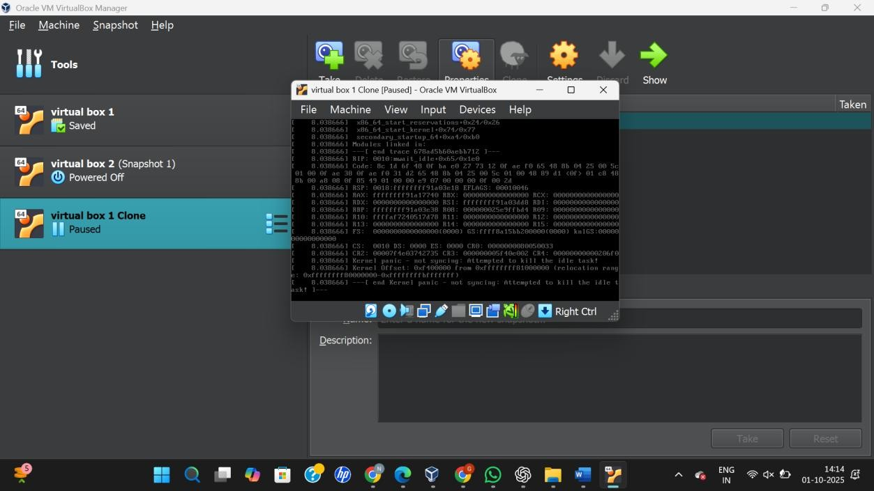

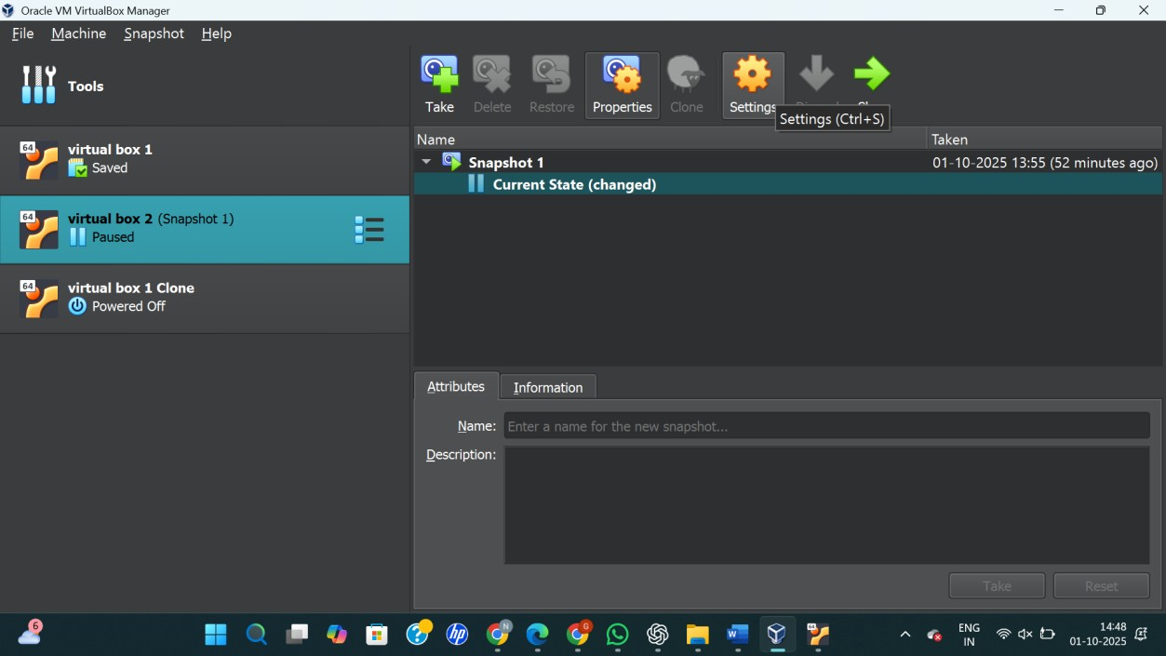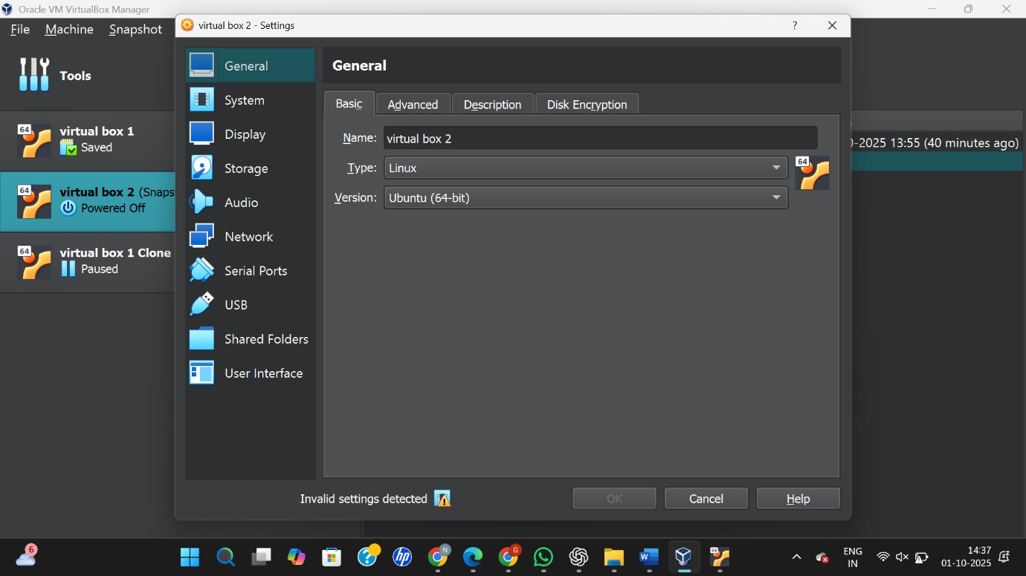

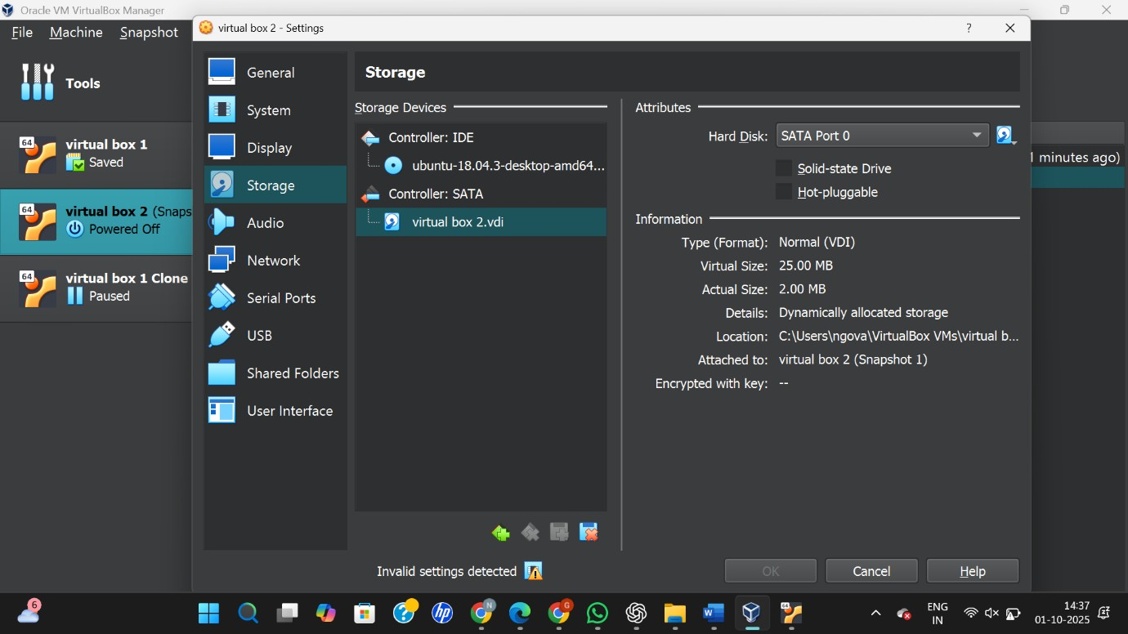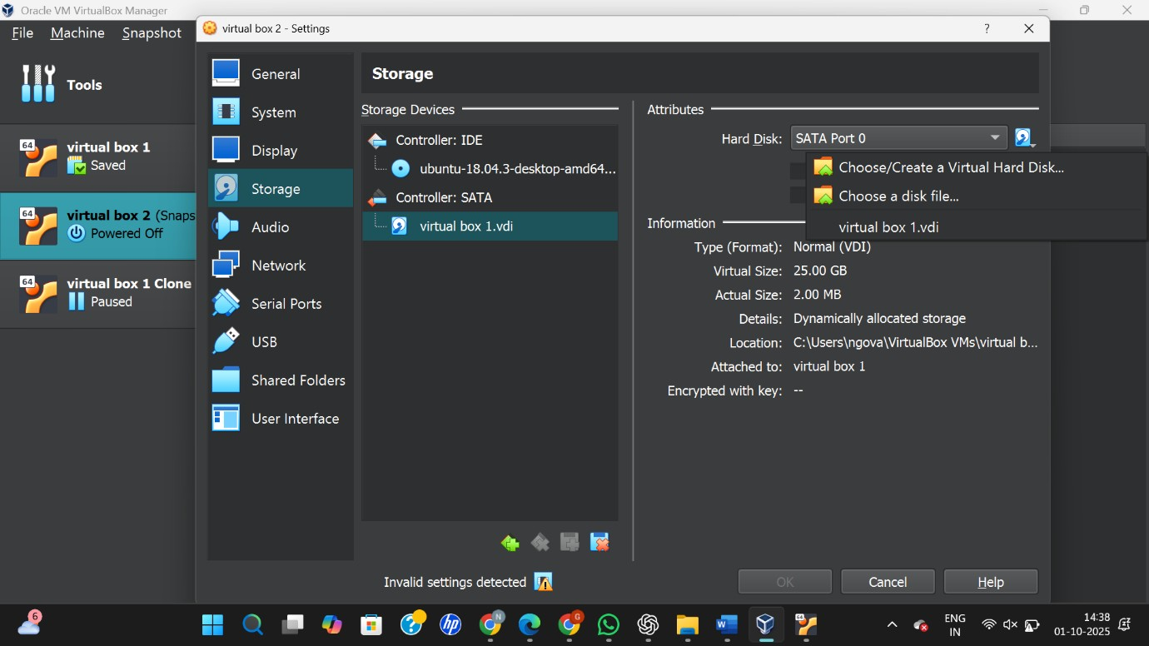
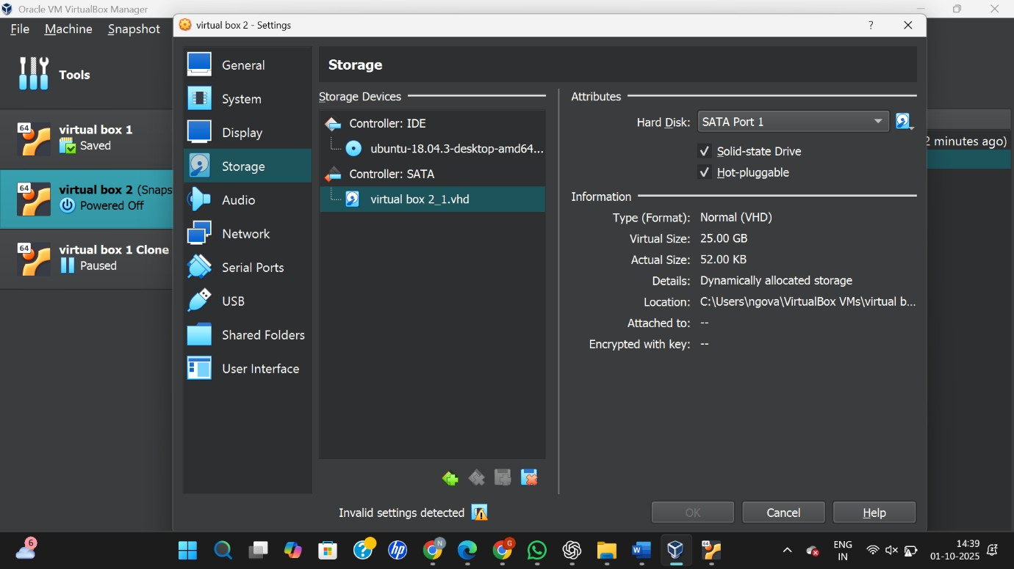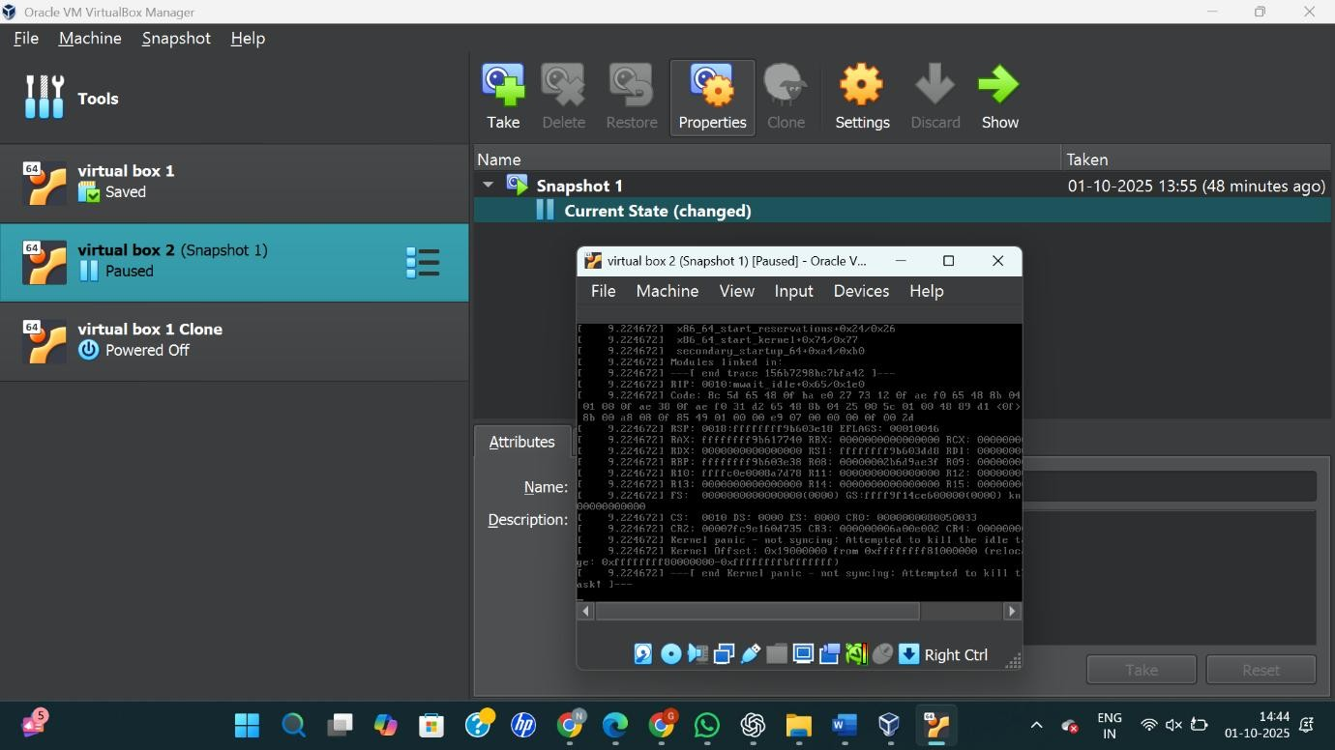

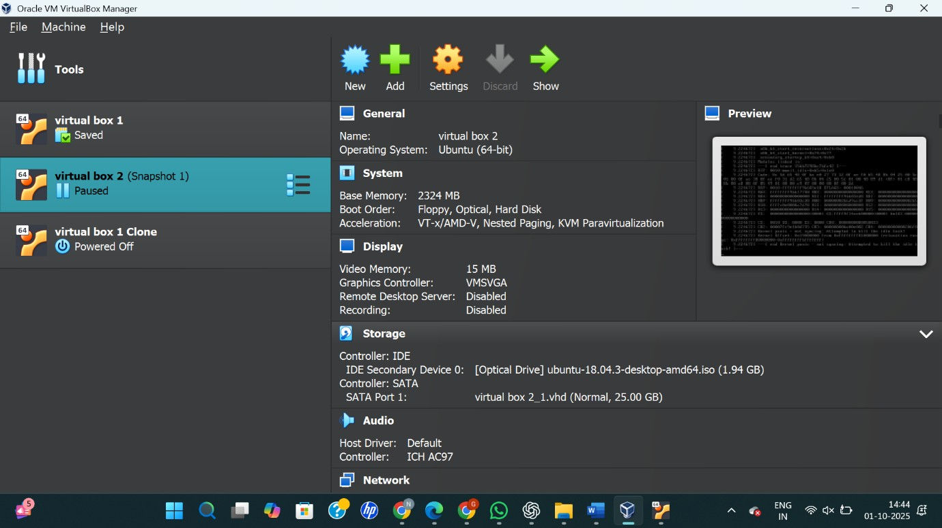
RESULT:
The hardware compatibility of the VM was successfully changed by modifying its configuration or cloning it in Oracle VirtualBox.

